Creating a Calm Box
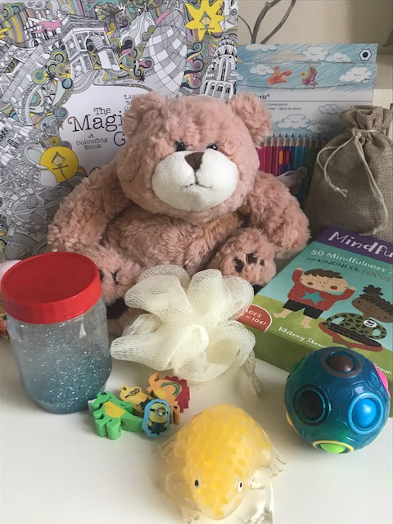
What is a Calm Box?
A Calm Box is a helpful resource for children that sometimes struggle to regulate their emotions and behaviour. As the name suggests, it is designed to help a child feel calm and to slow down when they may have moments of struggling with their thoughts, feelings or behaviour. For children with Autism, particularly with Pathological Avoidance Disorder (PDA), and for those children with Oppositional Defiant Disorder (ODD) a Calm Box might also be offered as a preferred activity.

Which Children would benefit from a Calm Box?
A Calm Box is personalised to meet the needs of the individual child. Children struggling with anxiety or expressing lots of anger may find it helpful to have a Calm Box filled with items that help them to feel able to relax and to regulate their emotions. Objects such as drawing or colouring books, bottles of bubbles and liquid timers are great.
Children with sensory needs or those that have a strong urge for tactile objects will find a Calm Box can provide relief. They can be filled with items that are safer for chewing and fiddling, as well as There are many sensory toys which are easily available now.
The important thing is that the child has a feeling of ownership over their Calm Box and that the items inside match their personal needs. The child may like to personalise the Calm Box and bring one or two things from home that they find help them.

What items could go into a child’s Calm Box?
Colouring books or pictures with colouring pencils
Paper and Pencils to draw
A soft, cuddly toy
A bottle of bubbles
Fiddle toys that can be manipulated
Expanding, squeezable or weighted balls
Puzzle toys
Sand, bubble or liquid timer
Glitter jar
Favourite story books
Tactile objects e.g. playdough, novelty rubbers, shower sponges and slime
Objects with scents e.g. lavender bags, scented tealights, soaps
Headphones for quiet, stories or music
Coping cards or breathing activities
Favourite photographs

